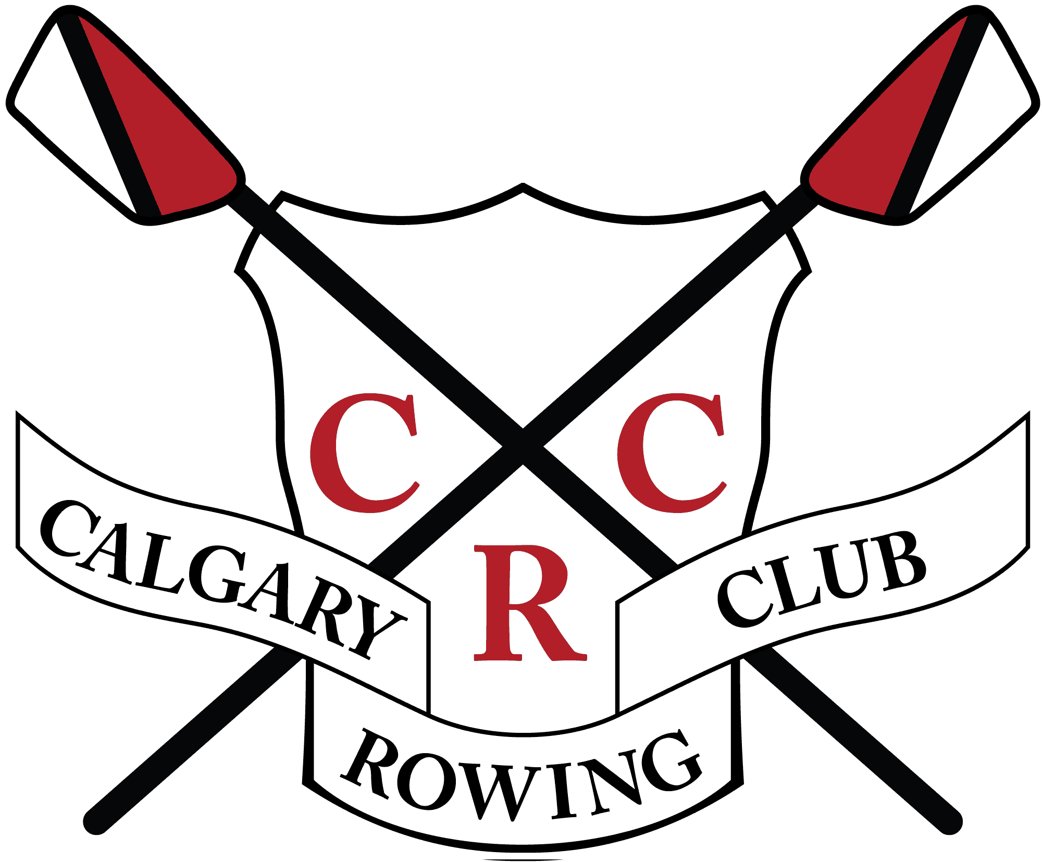
PO Box 36117 - 6449 Crowchild Trail S.W.
Calgary – Alberta T3E 7C6
Tel.: 249-2880 Fax: 240-9823
office@calgaryrowing.com
www.calgaryrowing.com

Job Posting

Position: Summer Equipment Staff
Location: Calgary, Alberta
Application Closing: March 1^{st,} 2024
Start Date: May 1st, 2024.
End Date: August 31st, 2024.

Overview
The CRC is a successful rowing club that provides a community environment to foster a passion for the sport of rowing and support athlete development. Founded in 1966 on the shores of the Glenmore Reservoir, the CRC provides year-round competitive and recreational rowing programs for all skill levels. Athletes from the CRC compete successfully at local, national and world levels. The CRC takes equal pride in developing both high-level athletes as well as giving hundreds of people the chance to experience the joy of rowing.

About this position

The Calgary Rowing Club (CRC) is seeking a qualified Summer Equipment Staff member who shall be primarily responsible for all repair and maintenance of the CRC fleet and equipment. The Summer Equipment staff will track, record, and perform all repairs on boats, oars, and club equipment. They will assist the Club Manager with parts inventory and orders. The Summer Equipment staff is a role model for newcomers, as well as experienced athletes, and their ability to handle stressful situations in a mature manner along with strong conflict resolution skills are paramount in ensuring that everyone at the CRC has a fun and successful summer. The Summer Equipment staff will work collaboratively with a team of summer staff to provide quality programs at the CRC between May and August. The Summer Equipment Staff reports directly to the Club Manager and Assistant Club Manager if applicable.

Responsibilities and Duties

- Repair and maintain all CRC equipment including but not limited to boats and oars
  - Safely use hazardous materials and power tools to repair equipment using appropriate techniques (carbon fiber and fiber glass repairs)
  - Maintain a clean, safe, and organized working environment
  - Keep track and log all repairs using iCrew software
  - Communicate damages and required repair to Club Manager.
  - Maintain the parts inventory and inform Club Manager if parts orders need to be made.
- Assist with and instruct Learn to Row, high-school, private and corporate LTR programs.
- Assist program coaches with their respective regular programs during work hours as needed.
- Assist Club Manager with regatta planning and set up.
- Assist with welcoming new members to the Club. Help new members find their way around the club.
- Assist Club Manager with coordination of Club-wide events including the AB Open, Novice regatta among others.
- Assist Equipment Manager with regatta preparations (packing for trailer loading, etc.).
- Assist Club Manager with maintaining the club’s social media including CRC website, Facebook, Instagram (if applicable).
- Assist Club Manager with executing the Youth Camp and LTR media campaign.
- Assist with day-to-day management of boathouse activities (membership demands, program demands, keeping boathouse tidy, etc.).
- Assist with club clean-up as required.
- Other duties as assigned by the Club Manager.

Training
- Staff will receive training regarding:
  - Learn To Row and Youth Camp coaching (RCA LTR Coach).
  - Safe operation of safety boats.
  - Safety procedures at the CRC.
  - Safe handling of materials used for boat repair (PPE provided).
  - Rigging training.
Opportunities to advance coaching skills and training are available to those who desire.

Nature of the Position
This is an hourly position that requires approximately 40 hours of work per week. Hours may include working on weekends or holidays. The hours of this position seek to meet the businesses’ needs.

Qualifications
- Preference given to applicants with rowing shell repair experience (carbon fiber, fibre glass repairs and rigging skills).
- Knowledge of the sport of rowing.
- Ability to coach sweep and scull rowing.
- Coaching experience preferred.
- CPR-C and AED certification.
- Pleasure Craft License.
- Successful completion of a Criminal Background Check with Vulnerable Sector Search.

If you believe you will be an ideal candidate, please forward your resume and cover letter titled “First Name.Last Name – Summer Equipment staff” stating your experience to: ofﬁce@calgaryrowing.com.

***This position is part of the Canada Summer Jobs program. Please note that the position relies on funding from Canada Summer Jobs***

